Assignment on AWS Deployment
Assignment on AWS Deployment
Deploying Flask Backend and Express Frontend

Introduction
This assignment demonstrates how to deploy a full-stack application consisting of a Flask backend and an Express (Node.js) frontend using Amazon Web Services (AWS).
You will learn three deployment strategies:
- Single EC2 instance deployment
- Separate EC2 instances deployment
- Containerized deployment using ECR, ECS, and VPC

Prerequisites
Before starting, ensure you have:
- AWS Account (Free Tier recommended)
- GitHub account
- Basic knowledge of:
  - Flask (Python)
  - Express (Node.js)
  - Git & GitHub
  - Linux commands

PART 1: Deploy Flask & Express in a Single EC2 Instance
Step 1: Launch EC2 Instance
- Go to AWS Console → EC2 → Launch Instance
- Choose:
  - OS: Ubuntu
  - Instance Type: t2.micro (Free Tier)
- Allow ports:
  - 22 (SSH)
  - 80 (HTTP)
  - 3000 (Frontend)
  - 5000 (Backend)

Step 2: Connect to EC2
ssh -i your-key.pem ubuntu@your-public-ip

Step 3: Install Required Software
sudo apt update
sudo apt install python3-pip nodejs npm git -y

Step 4: Clone Your Repository
git clone https://github.com/your-username/your-repo.git
cd your-repo

Step 5: Setup Flask Backend
cd backend
pip3 install -r requirements.txt
python3 app.py
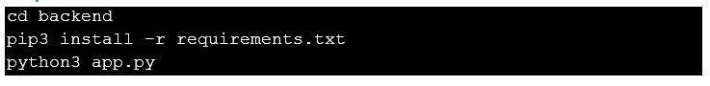

Step 6: Setup Express Frontend
Open a new terminal or run in background:
cd frontend
npm install
npm start
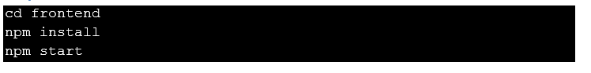

Step 7: Access Application
- Backend → http://<EC2-IP>:5000
- Frontend → http://<EC2-IP>:3000

PART 2: Deploy in Separate EC2 Instances
Step 1: Create Two EC2 Instances
- Instance 1 → Flask Backend
- Instance 2 → Express Frontend

Step 2: Setup Backend EC2
sudo apt update
sudo apt install python3-pip git -y
git clone <repo>
cd backend
pip3 install -r requirements.txt
python3 app.py

Step 3: Setup Frontend EC2
sudo apt update
sudo apt install nodejs npm git -y
git clone <repo>
cd frontend
npm install
npm start

Step 4: Connect Frontend to Backend
- Replace API URL in frontend code:
const API_URL = "http://<BACKEND-IP>:5000";

Step 5: Access Application
- Frontend URL → http://<FRONTEND-IP>:3000

PART 3: Docker Deployment using ECR, ECS & VPC

Step 1: Create Dockerfiles
Backend Dockerfile
FROM python:3.9
WORKDIR /app
COPY . .
RUN pip install -r requirements.txt
CMD ["python", "app.py"]
Frontend Dockerfile
FROM node:18
WORKDIR /app
COPY . .
RUN npm install
CMD ["npm", "start"]

Step 2: Build Docker Images
docker build -t flask-backend .
docker build -t express-frontend .

Step 3: Push Images to AWS ECR
- Create repository in ECR
- Login:
aws ecr get-login-password --region your-region | docker login --username AWS --password-stdin <repo-uri>

- Tag & Push:
docker tag flask-backend <repo-uri>
docker push <repo-uri>

Step 4: Create ECS Cluster
- Go to ECS → Create Cluster
- Choose Fargate

Step 5: Create Task Definition
- Add two containers:
  - Flask Backend
  - Express Frontend
- Set ports:
  - 5000 (backend)
  - 3000 (frontend)

Step 6: Run Service
- Launch service in ECS cluster
- Configure networking using VPC

Step 7: Access Application
- Use Load Balancer URL provided by ECS

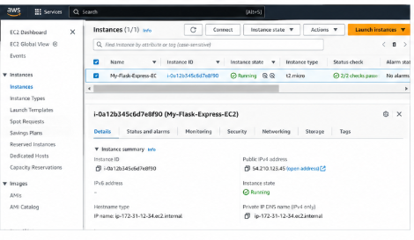
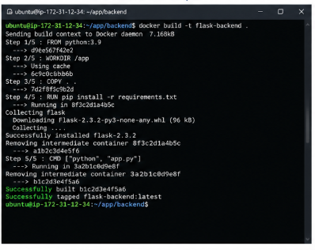

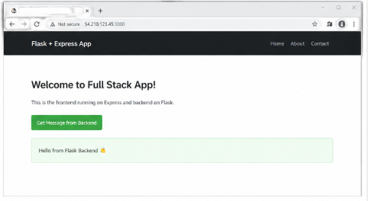

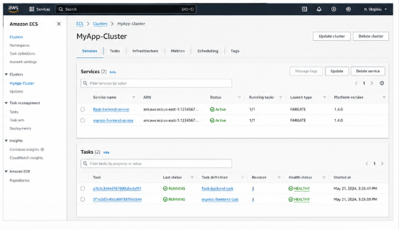

GitHub Repository Structure
project/
│── backend/
│ ├── app.py
│ ├── requirements.txt
│
│── frontend/
│ ├── app.js
│ ├── package.json
│
│── docker/
│ ├── Dockerfile.backend
│ ├── Dockerfile.frontend

Conclusion
This assignment covers:
- Traditional deployment (EC2)
- Scalable architecture (multiple EC2)
- Modern container-based deployment (ECS + Docker)
By completing this, you gain real-world DevOps and cloud deployment experience.

